8.33: Take east to be the x-direction and north to be the y-direction (again, these choices are arbitrary). The components of the common velocity after the collision are

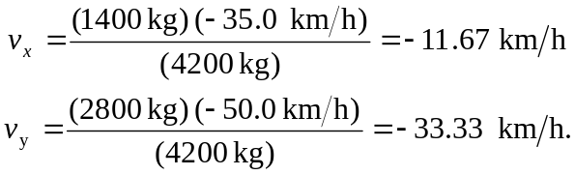
The velocity has magnitude and is at a direction arctan 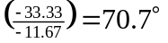 south of west.

